NEW
PRODUCT
NEWS

See Sierra At
AUTOMOTIVE TESTING BOOTH #
8026

Sierra Introduces Engine Air Intake Mass Flow Meter for Engine Testing Applications at Automotive Testing Expo

Lansing, MI – October 17, 2008 – Sierra Instruments’ Emissions Systems Division will show their Air-Trak™ Model 628S Engine Air Intake Mass Flow Meter at the Automotive Testing Expo in Novi, Michigan on October 22-24, 2008. The Air-Trak™ Model 628S, originally designed to work specifically with Sierra’s Model BG®-3 Partial Flow Sampling System as an extremely fast, accurate, and repeatable engine air intake mass flow meter, is now offered as an excellent solution across the board in all engine testing applications.

Air-Trak™ is specifically designed to measure engine air intake mass flow rate. The meter uses Fast-Flo Sensor Technology® for an extremely fast, 200 millisecond response-time making it ideal for the toughest transient test cycles. Integral Dual-Plate laminar flow conditioning elements and a wide 15:1 turndown make Air-Trak™ a flexible solution for the constrained piping environments commonly found in today’s engine test cells.

In addition, the versatile microprocessor-based instrument integrates the functions of flow-range adjustment, meter validation and diagnostics encased in a probe-mounted NEMA 4X (IP65) housing. Mass flow rate and totalized flow, as well as other configuration variables, are displayed on the meter’s 2 x 12 backlit LCD panel. Air-Trak™ also provides an optical/galvanic, isolated 4-20 mA output or 0-5 VDC output and two alarm outputs. The programmable transmitter is easily configured via RS 232 communications and Sierra’s Smart Interface TM WindowsTM based software or manually with three push buttons inside the instrument. Air-Trak™ is available in body sizes from 1 inch to 24 inches (316 stainless steel tubing).

For complete technical information on the Air-Trak™ Model 628S visit www.sierraemissions.com or call 800-866-0200 and speak to one of Sierra’s flow experts.

Sierra Instruments Inc., 5 Harris Court, Building L, Monterey, CA 93940
PH (800) 866-0200, FAX (831) 373-4402
MORE

FOR IMMEDIATE RELEASE

Press Contact:
Maryadine Washington,
Marketing Communications Manager
831-373-0200
FAX 831/-373-4402
m_washington@sierrainstruments.com

Technical Contact
Del Pier, Product Manager
517-669-0514
FAX: 517-669-5975
del-sierraemissions@comcast.net
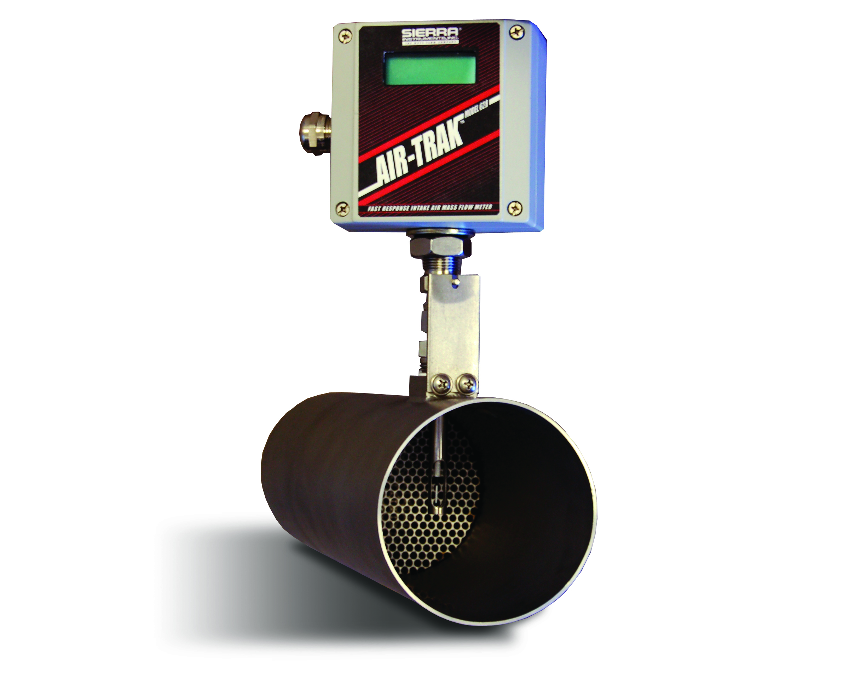
Air-Trak™ Model 628S

See Sierra At
AUTOMOTIVE TESTING BOOTH #
8026

About Sierra Instruments Emissions Systems

• Sierra Emissions Systems is a wholly owned subsidiary of Sierra Instruments, Inc.
• Sierra Instruments, Inc. is well known as " The Mass Flow Company " and manufactures high-performance mass flow meters and controllers for use in numerous industries and applications throughout the world.
• In 1990 Sierra received the exclusive worldwide license for Caterpillar patented micro-dilution technology.
• Sierra's knowledge of mass flow measurement and control, a key to partial flow sampling, and Caterpillars vast engine development and emissions testing knowledge formed a formidable technology partnership.
• For well over a decade, this technology partnership has yielded a line of world-class partial flow sampling systems: The Model BG®-1, Model BG^{®-}2, and now the very versatile Model BG®-3 provides accurate, repeatable Engine Particulate Matter (PM) emissions measurements for transient and steady-state engine and vehicle testing.

Learn more about Sierra Instruments Emissions Systems at www.sierraemissions.com .

####

FOR IMMEDIATE RELEASE

Press Contact:
Maryadine Washington,
Marketing Communications Manager
831-373-0200
FAX 831/-373-4402
m_washington@sierrainstruments.com

Technical Contact:
Del Pier, Product Manager
517-669-0514
FAX: 517-669-5975
del-sierraemissions@comcast.net
Air-Trak™ Model 628S

